Phishing Awareness Kit

Introduction
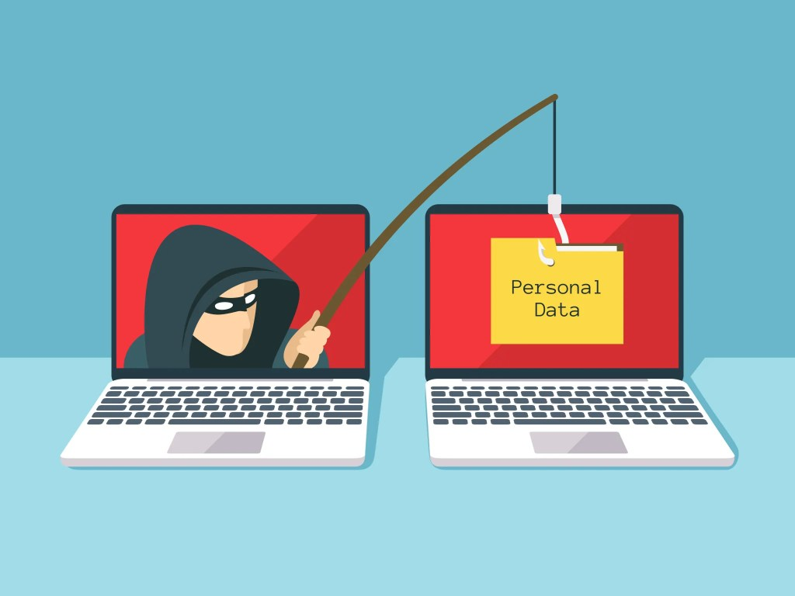
Phishing attacks are a popular way of stealing information. Fake communications led by criminals who pretend to be real businesses or services. These fake communications are becoming more prevalent. They are intricate, exploit user trust, and create a false sense of urgency to extract more data. The "Phishing Awareness Kit" project is designed to help the users understand the phishing attempt and the phishing signs which are the greatest red flags in the attempts. This project aims to address online safety and the best practices to avoid becoming a victim of these phishing schemes. This project hopes to increase cybersecurity and decrease the phishing victimization rate.

Objective
The goal of this project is to build knowledge of phishing attacks and recognize basic phishing attempts. The project will discuss the operation of phishing schemes and how to identify the red flags in fake emails and websites. The project will also provide tips to remain vigilant in the cyber world.
The aim of the project is:
- To examine the meaning of phishing
- To identify the different types of phishing attempts
- To be able to spot the red flags in phishing emails and messages
- To potentially adopt a cyber hygiene behavior to thwart phishing attempts
- To build a user awareness project on phishing and promote a positive cybersecurity online culture.

What is Phishing?
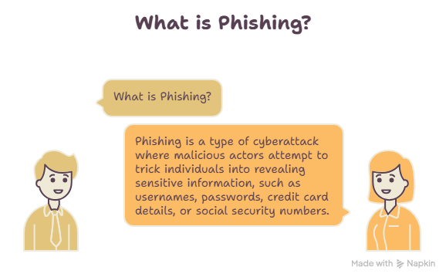
A phishing attack is a type of cybercrime in which the perpetrator poses as a legitimate person in order to convince the victim to give up sensitive or otherwise classified information. Email, text, phone calls, and fake websites are the most common tools to conduct a phishing attack. These schemes almost always have time-sensitive features in order for the victim to click the harmful links or provide classified information. Unlike other cybercrimes, phishing attacks do not focus on a direct attack to the system, but rather a behavioral exploit. Because of this, phishing schemes are the most common method used to conduct a cyber attack. The best ways to counter a phishing scheme is to examine the trustworthiness of a source, closely analyze hyperlinks, do not click or respond to questionable content and apply protective measures to your accounts, such as two-factor authentication (2FA). Knowing phishing schemes is the best way to protect your classified information.
Types of Phishing
There are many forms that phishing attacks can take. This is dependent on the way that cybercriminals trick their victims. Below are the most common forms of phishing.
- Email Phishing
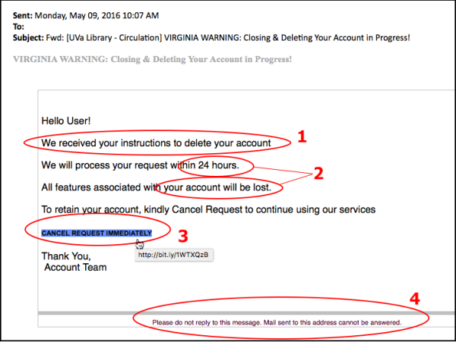
Email phishing remains the commonest kind of phishing scam where cyber criminals use deceptive emails that seem to originate from trustworthy sources such as banks and government institutions. The emails often contain dangerous links or attachments which invite clicking or leaking of personal information.

- Spear Phishing
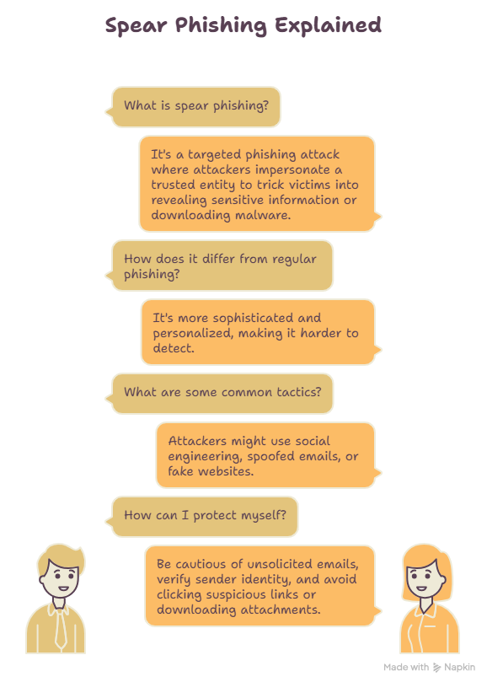
Spear phishing refers to phishing targeted at an individual or organization. The attackers obtain information about the target to make the message appear authentic and personalized.
- Smishing (SMS Phishing)
Smishing refers to the type of attack where phishing is done using SMS. Here, the attacker sends a message that contains either malicious links or directs the user to call a certain number.
Example: A text message saying, "Your bank account has been suspended. Click here to verify your identity."

- Vishing (Voice Phishing)
In Vishing, the attacker makes a call pretending to belong to a reputable organization. The goal is to make the victim give out passwords, OTPs, or even bank details.
Example: A caller claims to be from your bank and asks for your OTP to "verify your account."

- Clone Phishing
In clone phishing, the attacker replicates an email that the victim has received before, and replaces the attachments and/or links that were originally in the email with malicious ones.
Example: A caller claims to be from your bank and asks for your OTP to "verify your account."
Type of Phishing | Method Used | Example
Email Phishing | Fake emails | Fake bank or shopping website emails
Spear Phishing | Personalized emails | Email targeting a specific employee
Smishing | SMS messages | Fake banking text messages
Vishing | Phone calls | Fake customer support calls
Clone Phishing | Copied legitimate emails | Fake invoice or document download

How to Detect a Phishing Attack
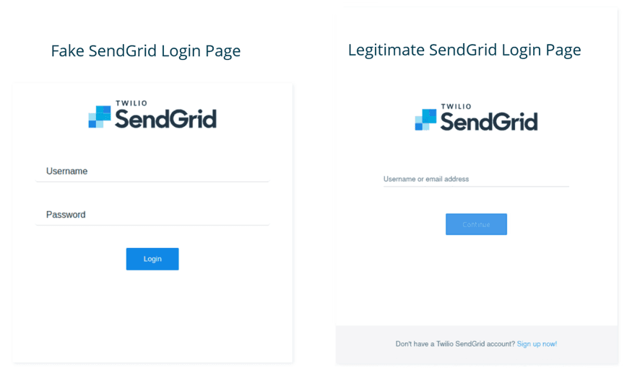
Phishing attacks are supposed to seem credible but there are several features that will allow you to distinguish between legitimate emails and phishing attempts.

1. Check the Sender’s Email Address
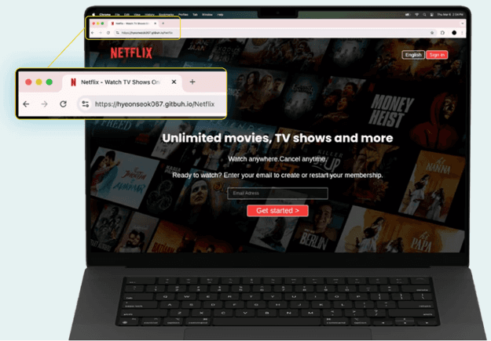
Do not open an email and do not follow any links until you are sure of the sender’s email address. In most cases, phishing emails use addresses that seem similar to real ones but have minor differences like additional letters or numbers.
Example:
- Real: support@amazon.com
- Fake: support@amaz0n-security.com

2. Watch Out for Urgent and Threatening Messages
Phishing emails tend to cause panic in users and tell them about potential suspension of their accounts or failed payments.
3. Look at Links Before You Click on Them
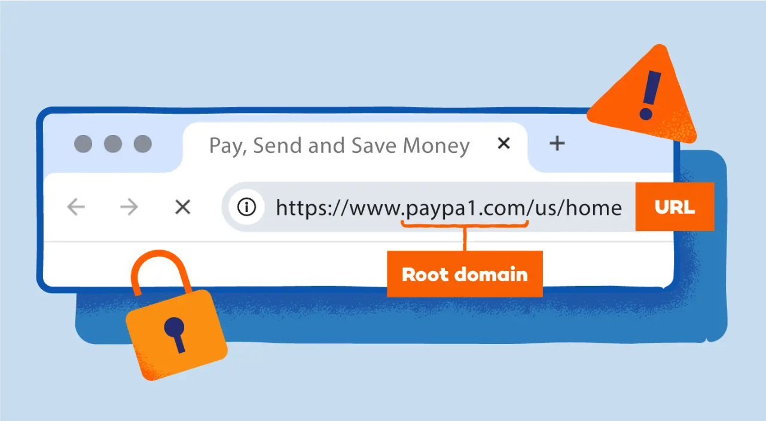
Before following any links, hover over them with your cursor to check the actual website you are going to be redirected to. If the address seems suspicious or includes random elements, do not follow the link.
Example:
- Safe: https://www.amazon.com
- Dangerous: http://amazon-login-security.xyz

4. Look for Errors in Spelling and Grammar
Most phishing emails tend to have mistakes in spelling or grammar or awkwardly phrased statements. Professional entities always make sure that they do not have any errors in their written communications.

5. Do Not Open Unknown Attachments
Never open attachments sent by unknown or unintended sources as the attachment can contain malware or ransomware which installs itself when the attachment is opened.

6. Never Disclose Sensitive Information
Professional firms never ask for any personal information like passwords, OTPs, or other banking details via email or SMS messages.

How to protect yourself from Phishing
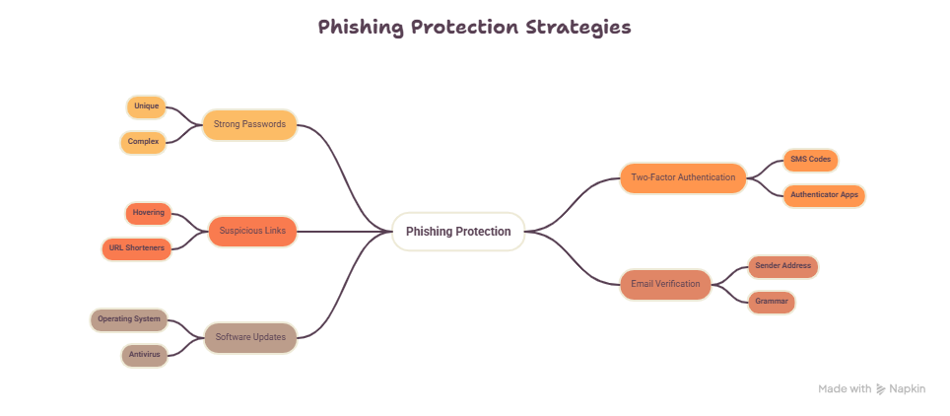
Despite the fact that phishing attacks are becoming sophisticated, there are several ways to minimize the probability of being a victim of a phishing attack through practicing cybersecurity tips. Here is how one can protect his personal information and finances from phishing attacks.

1. Check the Sender
It is highly important to always look at the email address of the sender of the email. If the sender address is unfamiliar or looks unprofessional, do not open the message.

2. Do Not Open Unfamiliar Links
Do not click on the links that you receive via emails, text messages or even via social networks' messages. In case you have to visit the website, type the official URL of the website yourself in the browser bar.

3. Create Secure Passwords
It is essential to create strong and unique passwords. Remember that it is highly dangerous to use the same password for all accounts.

4. Use Two-Factor Authentication (2FA)
Two-factor authentication involves adding another factor of security in addition to your username and password to make sure your login process is secure. For example, the system sends an OTP to your phone number or generates an authentication app code.

5. Keep Your Software Up To Date
Always keep your OS, web browser, antivirus, and all other programs up to date. It helps protect your computer from new vulnerabilities that software developers patch in updates.

6. Be Careful With Attachments
Do not open attachments in emails unless you have received a message with an expected attachment from someone you know and trust.

Conclusion

Phishing continues to be one of the prevalent cyber threats faced by people in the contemporary digital world. Cybercriminals employ a variety of means including emails, instant messages, calls, and fake websites to get sensitive information from unsuspecting users including passwords, banking information, and personal data. With phishing techniques constantly changing, it is vital to stay vigilant and well-informed.

The current project has elaborated on the notion of phishing and provided information on its main types, warning signs, and methods of preventing the attacks. Adhering to some basic cybersecurity practices like verifying the sender, not clicking suspicious links, creating strong passwords, and using two-factor authentication (2FA) will decrease the chances of falling victim to the attacks.

To conclude, awareness plays one of the major roles when it comes to protection against phishing. Educating people on this type of cybercrime can help ensure better cybersecurity.

Thank You

